


Test Project
Graphic Design Technology

Corporate Identity
WSA2023_TP3_Corporate Identity
Time: 6 Hours
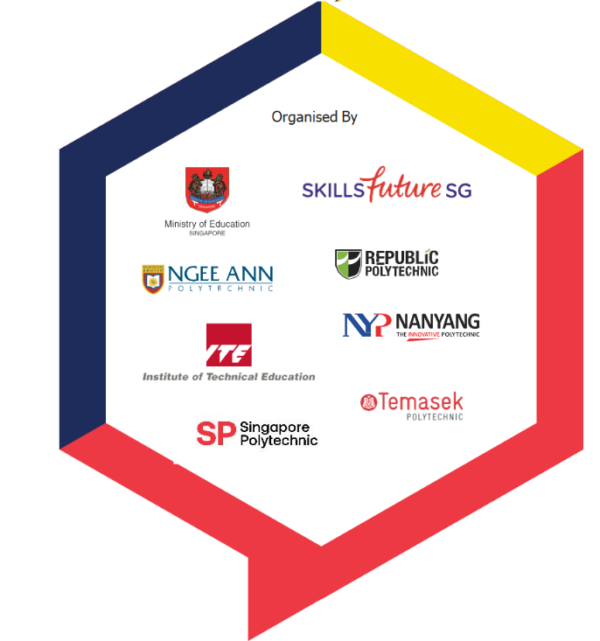
Submitted By: | Country
Ronald P. Alvarez | PH
Ganjar Satrio | ID



Contents
- Briefing of the project page 3
- Description of the project page 4
- Target audience page 4
- Task to perform page 4
- Description of the Task
- Task 1 page 5 - 7
- Task 2 page 8-10
- Task 3 page 11-12
- Instructions to the Competitor page 13

Appendix
- Appendix_1_Logo_.docx
- Appendix_2_Website.docx
- Appendix_3_Video.mp4
- Appendix_4_Instagram-Text.docx
- Appendix_5_Instagram-Post (image folder)
- Appendix_6_Campaign (image folder)
- Appendix_7_Social Media Icon (image folder)
- Appendix_8_ACAN logo.eps

Briefing of the project

Introduction

About the Organization:
The ASEAN Climate Action Network (ACAN) is a collaborative network of non-governmental organizations (NGOs) in Southeast Asia. Its goal is to address the impact of climate change in the region. ACAN's member organizations work together to raise awareness of the pressing need for action to mitigate climate change and to promote sustainable practices that will reduce the region's carbon footprint. By collaborating on regional initiatives, ACAN's members share resources and knowledge to develop innovative solutions that can make a real difference. ACAN works tirelessly with its member organizations to ensure that the voices of local communities and stakeholders are heard.
The organization promotes sustainable energy and climate-resilient development in the region while engaging in extensive research and analysis to identify effective solutions for addressing climate change. ACAN advocates for strong national and international policies to address climate change by working closely with policymakers and stakeholders at all levels.
ACAN's campaign SmallChangesBigImpact aims to encourage individuals and businesses to adopt sustainable practices in their daily lives and operations. Through this campaign, ACAN hopes to raise awareness about the importance of sustainable development and inspire positive action toward a greener future.

The objective of the test project

WHAT: Design a new campaign logo and visual materials for the SmallChangesBigImpact campaign.
WHY: The purpose of this design exercise is to create a campaign logo and visual materials that will be shared on the website & social media to raise awareness of the organization's campaign. The campaign combination mark will not replace the organization's existing logo but will serve as a visual campaign that supports the organization's mission.
HOW: This project is an opportunity to showcase your creative skills by interpreting ACAN's vision and mission through a new logo campaign and various applications. By submitting different proposals, participants will generate a diverse range of designs and increase the visibility of the ACAN Campaign. Consider this project as a playground to express your own visual voice.

Description of the project
Target audience
The SmallChangesBigImpact campaign targets environmentally conscious individuals and organizations seeking to reduce their dependence on fossil fuels. This includes homeowners, small business owners, and larger corporations interested in reducing energy costs and having a positive impact on the environment through investments in renewable energy sources. The target audience is also interested in reducing their carbon footprint and has moderate to high disposable income.
Demographics

- Homeowners: These individuals are interested in reducing energy bills and having a positive impact on the environment through investments in solar panels, wind turbines, or other renewable energy sources.
- Small business owners: These individuals are interested in cost-effective ways to reduce energy costs and be more sustainable. Renewable energy solutions can help achieve these goals.
- Corporations: These organizations have large-scale renewable energy systems and are interested in reducing their carbon footprint to meet sustainability goals. Investments in large solar farms or wind turbines can help reduce carbon footprint and save money on energy costs.
It is important to remember that the target audience for SmallChangesBigImpact is environmentally conscious, technologically savvy, and looking for cost-effective solutions. The campaign should reflect the organization's focus on sustainability and innovation and should appeal to the target audience's desire to reduce their impact on the environment and lower their energy costs.

Task to perform

- Task1: Develop a Logo for the SmallChangesBigImpact Campaign within 2.5 hrs
                - (Submit before lunch)

Task 2 & Task 3 , 3.5hrs Submit after lunch
- Task 2: Develop an interactive website pages with 3 navigation menu: Home, About Us & Campaign
- Task 3: Design social media campaign posts with motion graphics for the ACAN Instagram page

Task 1: Develop a logo for the SmallChangesBigImpact Campaign.
(Submit before lunch)

Create:
Create a unique and memorable campaign logo that represents the core message of the campaign. Incorporate elements such as greenery, sustainability symbols, and a sense of growth or transformation to visually communicate the impact of small changes.
Logo Requirements:
- Vector only
- The logo must be a combination mark (Logotype and Logomark combined into one logo).
- The logo should NOT include any gradients.
- The logo must include the following text
○ Logo Text: SmallChangesBigImpact
You can use upper, lower, or upper & lower case for your stylization. You can also adjust the word spacing of the text if you want.

Logo variations
- PMS version
- CMYK version
- RGB version
Produce:
Technical Specifications
- Create your logo on A4 artboard
- Show ideas and development through sketches, you must have THREE (3) different sketches.
- Include these sketches in ‘Final Files’ (can be digital drawing sketches, photograph manual drawing sketches using iMac camera - Photobooth application)
- Trapping 0.40 pt. (if required)

Colour
- Your logo must only use TWO (2) ( Pantone+ CMYK Coated ) and ONE (1) SPOT Colour, must be (C:60, M:0, Y:20, K:0) with no tints or gradients (only 100% of colour is allowed)
- Convert to a CMYK and RGB version during submission using different file types
- CMYK and RGB versions should replicate the colors as closely as possible to each other. Should NOT have decimals (e.g. 2.73, change to 3).
- Include color swatches in each version including the color specifications of each color in PDF only.
Naming
Note: YY represents your Competitor number
- Logo file name: YY_Logo_PMS.ai
- Logo file name: YY_Logo_PMS.pdf
- Logo file name: YY_Logo_CMYK.pdf
- Logo file name: YY_Logo_RGB.pdf
- Font folder name: YY_Font_Folder
You must deliver
(Submit before lunch)
Digital

PMS File
- 1 x Ai File Without outlined text
- 1 x PDF/X-4:2008, all text must be converted to outlines and on separate plates

CMYK File
- 1 x PDF/X-4:2008, all text must be converted to outlines

RGB File
- 1 x PDF, all text must be converted to outlines

Font Folder
- includes fonts used for the logo

Print
- 1 x Print of combination mark Logo PMS design in A4 – format showing TWO (2) sizes of the combination mark. One large size is not larger than 15cm at the longest edge and the second size is not larger than 5cm at the longest edge (width or height).

- 1 x Print of THREE (3) combination mark logo variations on an A3 paper sheet mounted on an A3 black board.
- Workstation number on a separate name tag paste behind the mounting board
- 1 x A4 paper sheet THREE (3) combination mark logo sketches (No need to print if you are using manual sketch and If you are using digital sketches, you must print them on an A4 sheet of paper.)

Task 2: Design a user interface for the ACAN website.
Create:
Create 3 interactive website pages.
To effectively communicate program information and maximize visibility for the ACAN campaign, it is crucial to develop website pages that align with the campaign's message. As part of this effort, you have been tasked with designing THREE (3) website pages for ACAN.
To visually represent the campaign's target audience, create and use a graphic element that aligns with the combination mark logo from Task 1. It's important that this graphic element has unity with the combination mark logo created in Task 1.
Specifications
These elements must be included in your design:
- The requested interactive elements are indicated in <blue>.
- You may use images provided into your design.

Header & Footer for Pages 1 - 3 must include:
Header & Navigation
- Logo ACAN
- SmallChangesBigImpact Combination mark logo
- Text in Appendix_2_Website
- <Home navigation menu that goes to the home page when clicked>
- <About Us navigation menu that goes to the about us page when clicked>
- <Campaign dropdown (Registration) navigation menu that goes to the registration page when clicked>
- <Text Field for Search Bar>
- <Dropdown Menu Field “language ” for option>

Footer
- Text in Appendix_2_Website
- THREE (3) Social Media icons Appendix_7_Social Media Icon
<For EACH Social Media icon is clickable and goes to URL stated in the appendix>

Page 1 — Home page must include:
- Text in Appendix_2_Website
- Images from Appendix_6_Campaign
Carousel/Slider
- THREE (3) Images
- Text in Appendix_2_Website
- <Forward button icon that goes to the next image when clicked>
- <Back button icon that goes to the previous image when clicked>
Call to Action button
- <Call to Action button that goes to Registration page when clicked>
Page 2 — About US page must include:
- Text in Appendix_2_Website
- Images from Appendix_6_Campaign
Page 3 — Registration page must include:
- Text in Appendix_2_Website
Campaign
- Campaign logo
- Images from Appendix_6_Campaign

Technical Specifications
- Size : 1920px width by 1080px height
- Format : PDF interactive
- Color : RGB
- Color and ICC Profile : sRGB IEC61966-2.1
- Color blend : RGB (working spaces)
- Image resolution : 72 ppi at 100% in InDesign.
- Image format : PNG
- Viewing : Open in full-screen mode
- Include at least THREE (3) graphic elements that are related to the campaign logo from task 1.
- May include additional elements
Naming
Note: YY represents your competitor number

- Website file name: YY_Website.indd
- PDF interactive file name: YY_PDF_Website.pdf

You must deliver
Digital

- 1 x InDesign format file .indd working project native file, packaged and including linked files and fonts.
- 1 × PDF interactive file with interactive elements working.

Print
- 1 x Print of your THREE (3) website pages on A3 paper sheet

Task 3: Create a social media post using motion graphics for ACAN's Instagram account.
Create
Create an animated social media post using motion graphics and a thumbnail for the cover.
To maximize the spread of program information and attract the target audience for the client's campaign, social media posts with motion graphics are needed. You are requested to create a social media animation post with motion graphics.
The client expects high-quality deliverables that are visually appealing, innovative, and aligned with the campaign's message.
These elements must be included in your design:
- Use the text provided for each social media post (video) in Appendix_4_Instagram-Text
- Include the combination mark logo SmallChangesBigImpact from Task 1.
- Include the graphic element to show the campaign value.
- Use appropriate illustrations and/or Stock Photos to create motion graphics to support and help communicate to the audience in Appendix_5_Instagram-Post

Specifications
Social media post video
- Size : 1080px width by 1920px height
- Format : MP4 or MOV
- Video codec : H.264
- Frame rate : 30 FPS (frames per second)
- Duration : between 00:20 to 00:30 seconds in length
- Raster images : .tiff, .psd, .eps
- Vector images : .ai, .eps, .svg
- FOUR (4) screens only (See Appendix_4_Instagram-Text for text per screen)
Note: All texts must appear on each of the screen.
Your animation should be constructed in either Photoshop or After Effects

Social media post thumbnail/cover
- Size: 420px width by 654px height
- Format: .PNG

Naming
Note: YY represents your competitor number

- Social Media motion file name: YY_Social_Media_Post.psd or YY_Social_Media_Post.aep
- Social Media Post video name: YY_Social_Media_Post.mov or YY_Social_Media_Post.mp4
- Social Media Post thumbnail name: YY_Thumbnail.png
You must deliver
Digital
Provide assets for Instagram video posts:
- 1 x RGB video format: MP4 or MOV file type.
- 1 x Photoshop psd layered file or After Effects .aep working project native file, packaged and including linked files and fonts.
- 1 x .PNG file format file of your video thumbnail
Print
Nothing to print

INSTRUCTIONS TO THE COMPETITOR

TIME LIMIT FOR THIS TEST PROJECT
The Test Project module 3 must be completed in 6 hours

- Create a folder on your Desktop called YY_MOD3 (where YY represents the number of your workstation).
- This folder must include the following subfolders “Task 1, Task 2 and Task 3”. The subfolders are to contain two folders:

A folder named “Original”: it should contain all the files used for the development of your project.
A folder named “Final”: it should contain all of the final files. (PDF, native, fonts and linked images)
- You must include your workstation number on the presentation board and printouts for marking and delivery to your workstation (the number should be included outside of the artwork area)
- Regarding image assessment for the tasks: the colour mode of your images will be evaluated in the PDF files. The final resolution and file formats will be assessed in your working software, such as Illustrator or InDesign.
- The JPG file format is NOT ACCEPTED for images; only the following file formats are acceptable .TIF / .EPS / .AI / .PSD
- Task 1 must be created in Illustrator; Task 2 the final must be in InDesign; Task 3 final motion must be created in Photoshop or After Effects.
- Images must not be embedded or placed in Adobe Illustrator or Adobe InDesign.

